Enjoy the Benefits of Drinking Kangen Water

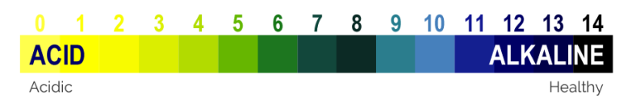
Kangen Water is a great way to increase hydration, balance body pH, obtain optimal health, neutralize free radicals, reduce pain, and more.

Clean, Refreshing and Tastes Great
Kangen Water is the best tasting water you can drink. It is smooth and refreshing. It will also enhance the taste of foods and beverages.

Detoxifying and Cleansing
When you have a buildup of acidic waste in the body, eventually you will need to have some sort of detox to cleanse yourself. Drinking Kangen Water is a simple and natural way to detoxify your body of impurities.

Micro-Clustered to Increase Hydration
Kangen Water is micro-clustered which means the actual water molecules are reduced in size allowing them to be easily absorbed by your body and deeply hydrate your cells.

Neutralize Free Radicals
Kangen Water has a very high negative ORP (Oxidation Reduction Potential) which makes it a powerful antioxidant. When consumed on a regular basis, the extra electrons in Kangen Water neutralize free radicals in the body.

Balance Body pH Over Time
Kangen Water helps raise the body’s alkalinity and fights against free-radicals that damage healthy cells. An alkaline body is a healthy body.

Powerful Antioxidant
Oxidation occurs naturally in nature. The rust on a pipe or a cut apple turning brown is oxidation. Oxidation in the body is known as aging. Kangen Water is a powerful antioxidant, 6-8 times more powerful than green tea.

Reduce Pain
Pain is something that many people deal with on a daily basis. Muscle soreness, joint pain, and stiffness are the most common. Kangen Water can reduce pain by helping the body become properly hydrated and allowing the acidic waste to be removed.

Improve Energy, Reduce Fatigue

Fatigue is a sign of your body being overly acidic. When your body dumps acidic and metabolic waste into your interstitial fluids, you have to be able to eliminate the buildup. If consumed on a regular basis, Kangen Water will help clean up the waste and improve your energy levels.

Improve Overall Health
Kangen Water is produced by Enagic Ionizers. They are approved as medical devices in Japan and are used in numerous hospitals and clinics because of the health benefits.
Five Life-Changing Waters in One Incredible Machine
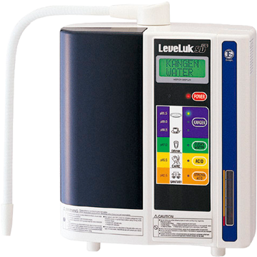

8.5-9.0 and 9.5 pH Kangen Water
Some call it “Miracle Water.” We’ll settle for “Really good for you.” There are three kinds: 8.5, 9.0, and 9.5 pH. This graduated approach allows users to build up to the maximum benefits. For some, the detoxification effect of Kangen Water requires an adjustment period. As it enters cells, it eliminates free radicals and helps heal damaged cells. This process is best conducted gradually. Kangen Water is rich in anti-oxidants so it diminishes the damaging effects of free-radicals. Its water molecule clusters are two-thirds smaller than ordinary water. This makes penetration of cellular tissue faster and easier. Its elevated alkalinity means it works in concert with the body to neutralize the acidity of the foods we eat. Your body is going to feel the difference with Kangen Water, and you’re going to experience – and appreciate – all the benefits.

2.5 pH Strong Acid – It Doesn’t get Cleaner than Sterile
You know what really wipes out nasty disease causing germs? A highly acidic environment.
That’s right, acid. Nothing calls acid home sweet home. Press the “Strong Acid” button on the LeveLuk SD 501, out comes water that is 2.5 pH or lower. That’s an extreme solution powerful enough to sanitize any surface or object, yet gentle enough to leave a nice sparkling sheen. It is such a powerful anti-bacterial that hospitals in Japan use it to clean surgery rooms – no additives, nothing else, just strongly acidic water.

11.5 pH Alkaline Water – Turning Coming Belief on its Ear
As the strong acid water is being made, the electrolysis process simultaneously produces water that is Strongly Alkaline – pH 11.5+. (Just accept this. If you ask why, there will be a long technical discussion just like the ones you slept through in Chem 101). This makes the perfect grease cutter. How perfect! Pour oil into a glass, and then pour in the 11.5 water. Convention says the oil will float to the top because of that conflict thing between oil and water, right? Wrong. The highly alkaline 11.5 pH water combined with the reduced size of the water molecule clusters actually binds with the oil, emulsifying it into a cloudy concoction. The water actually breaks down the oil. Just think what it’ll do with that oven you’ve been avoiding. Oh, and remember, it’s just water!

6.0 pH Beauty Water
One of the wonderful things about water is how refreshing it is. There’s nothing like a cool splash on the face to rinse away fatigue. Select “Beauty Water” on the LeveLuk SD 501 and that rise will not only feel good, it’ll be good for you. At a pH of 5.5-6.0, the Beauty Water exactly matches the pH of the skin. The small water clusters easily and quickly penetrate skin cells, revitalizing them while helping to maintain the perfect balance. With the high-concentration of anti-oxidants neutralizing the damaging effects of pesky free radicals, as the bad gets washed away, beauty is restored… and reinforced.

7.0 pH Clean Water
Sadly, we have to admit Kangen water isn’t for everyone. (Shock!) Babies are naturally higher in alkaline levels than adults, so they don’t need the added help Kangen provides big people. So, when it comes to the little ones, there’s a neutral pH setting (7.0 pH). This is great for them to drink (because it’s triple filtered), and it works well with formula. Oh, and there’s another group that needs to be alert when drinking Kangen water: folks on any type of medication – prescription or over the counter – that uses a time-released formula. It seems those small water clusters that are so great at emulsification and entering cell tissues work too well with such pills. Kangen water nullifies the time-release function by dissolving the pill quickly. This group needs to drink 7.0 clean water with time-release meds.

